

User guide for ICAf Conference management system



June 27, 2021

Y3S1_WE_GROUP_04

Contents

Features common to public

Login

Home page

Research publications

Workshop presentations

Download templates

Contact us

Registering to the system

As a research publisher

As a workshop presenter

As an attendee

Features common to logged in users

User profile

Features available for an admin

Admin board

Features available for a research publisher

Research publisher board

Features available for a workshop presenter

Workshop presenter board

Features available for an attendee

Attendee board

Features available for an editor

Editor board

Features available for a reviewer

Reviewer board for research publications

Reviewer board for workshop presentations

# Features common to public

## Login

## 

1. Click the link, “Login” pointed to by the arrow on the nav-bar to direct to the login page.

2. Enter login credentials.

3. Click on “Login” that is on the form.

## Home Page

This is ‘Home page’ where all the users are directed to when they open the application.

In the home page, the conference details which are approved by the Admin are displayed.

## Research Presentation

In the ‘Research presentation’ page, the research details which are approved by the Admin are displayed.

## Workshop Presentations

In the ‘Workshop presentation’ page, the workshop details which are approved by the Admin are displayed.

## Download Templates

This is where all the templates related to research publications, workshop presentations are available for download to anyone visiting the site.

1. 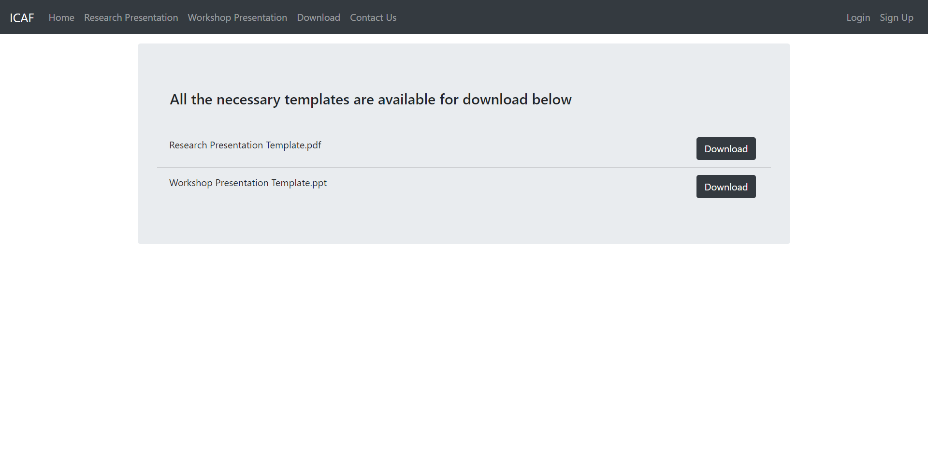Click the link, “Download” pointed to by the arrow on the nav-bar to direct to the page.
2. Click on any button denoted by “Download” from the list to download the relevant template.

## Contact Us

This is where all the users can get in touch for help or further information. A user can reach ICAF support with either the provided the contact details or “Submit” a message via the website.

# Registering to the system

## As a research publisher

1. 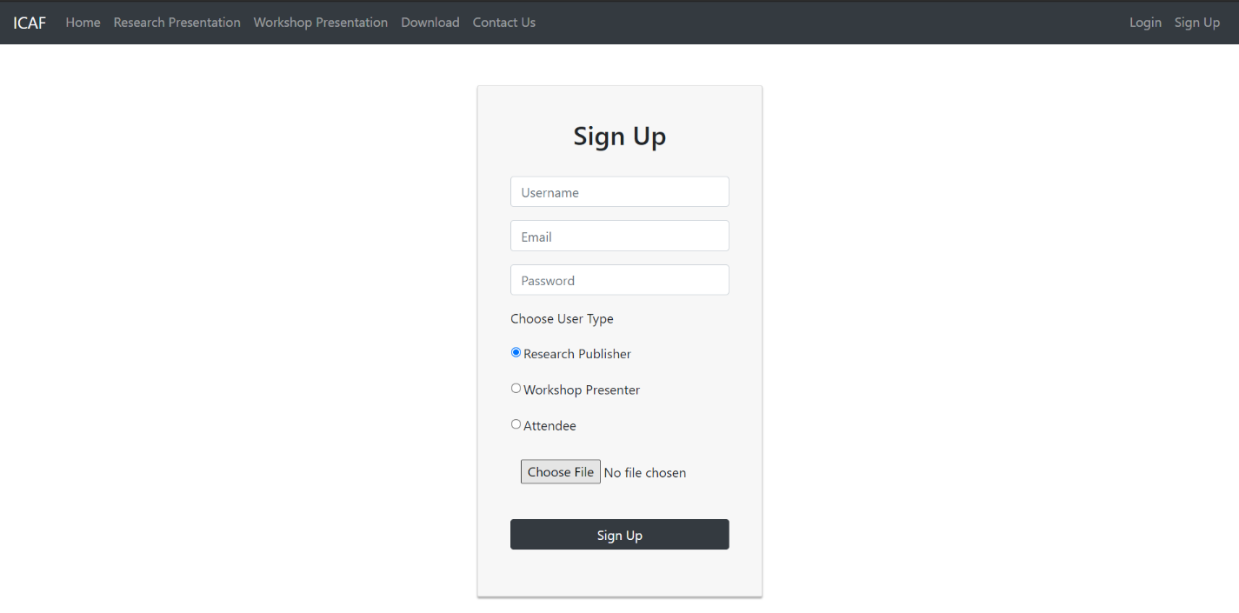Click the link, “Sign Up” pointed to by the arrow on the nav-bar to direct to the sign-up page.
2. Fill out the form.
3. Click the radio button denoted as “Research Publisher”.
4. Click on the button “Choose File” and choose the relevant file to upload as the research publication.
5. Click on “Sign Up” that is on the form.

## As a workshop presenter

1. Click the link, “Sign Up” pointed to by the arrow on the nav-bar to direct to the sign-up page.
2. Fill out the form.
3. Click the radio button denoted as “Workshop Presenter”.
4. Click on the button “Choose File” and choose the relevant file to upload as the workshop presentation.
5. Click on “Sign Up” that is on the form.

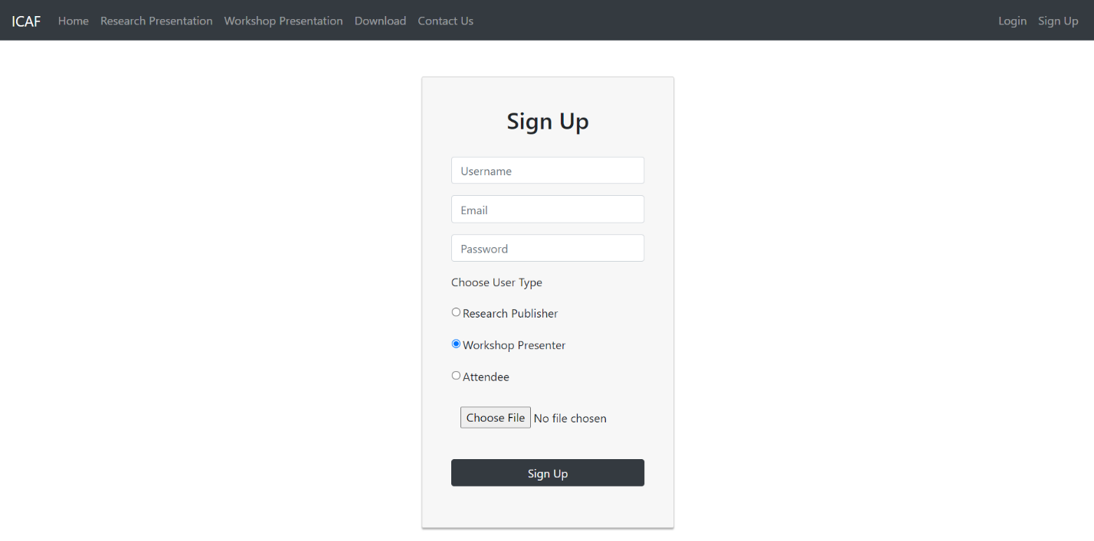

## As an attendee

1. Click the link, “Sign Up” pointed to by the arrow on the nav-bar to direct to the sign-up page.
2. Fill out the form.
3. Click the radio button denoted as “Attendee”.
4. Clicking the “Attendee” radio button extends the form to enter payment details.
5. Fill out the payment details.
6. Click on “Sign Up” that is on the form.

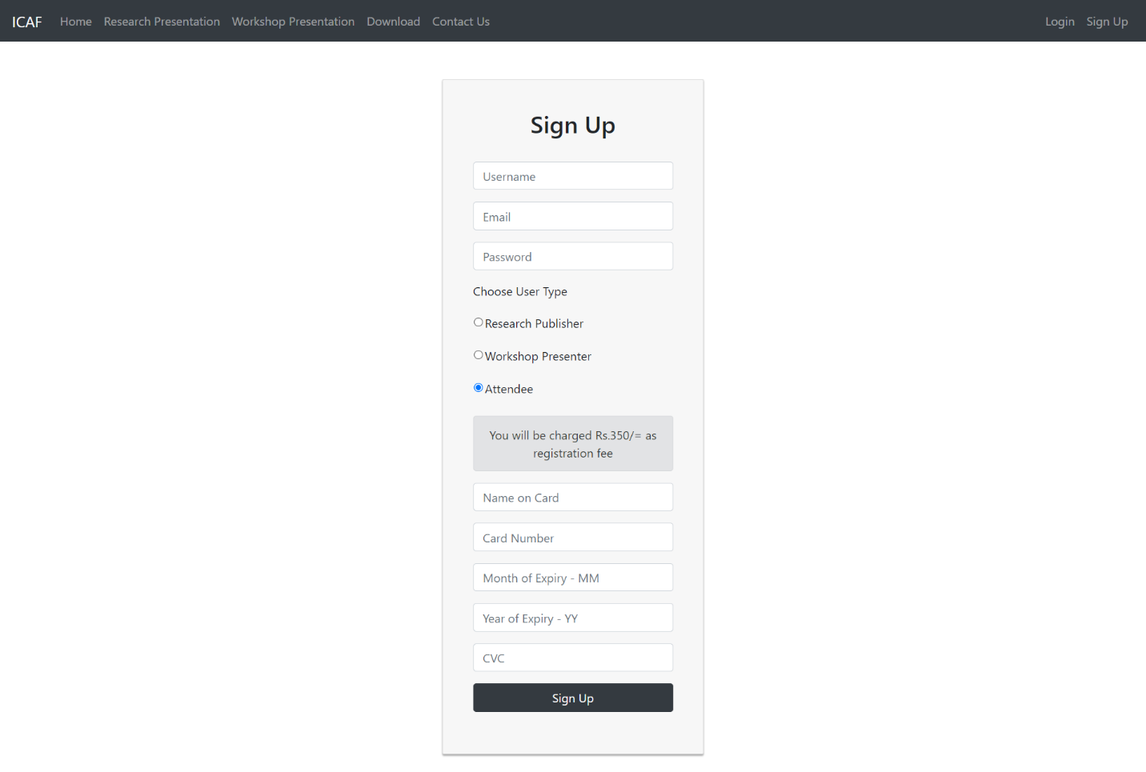

# Features common to logged in users

## User Profile

This the user profile where details related to the logged in user is displayed.

1. Login to the system (as any user).
2. Click the link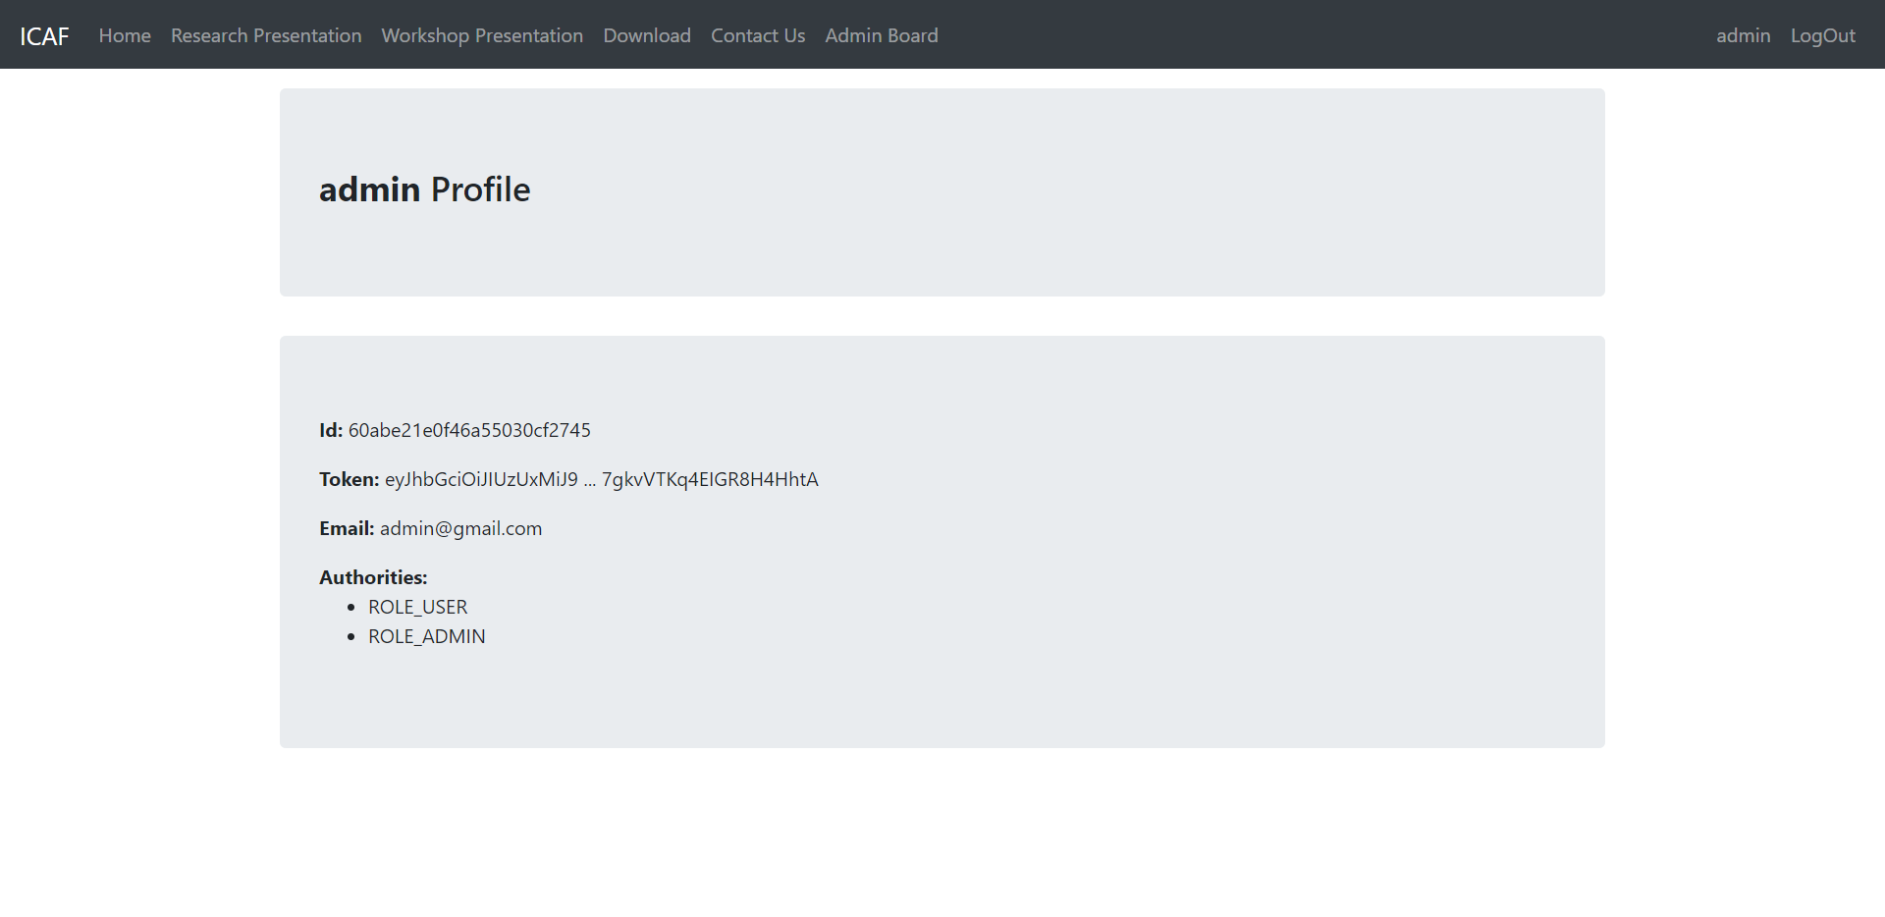 named after the username of the user, pointed to by the arrow on the nav-bar, to direct the user to the user profile.

# Features available for an admin

## Admin Board

1. Login to the system as an admin.
2. Click the link named “Admin Board”, pointed to by the arrow on the nav-bar, to be directed to the admin board.

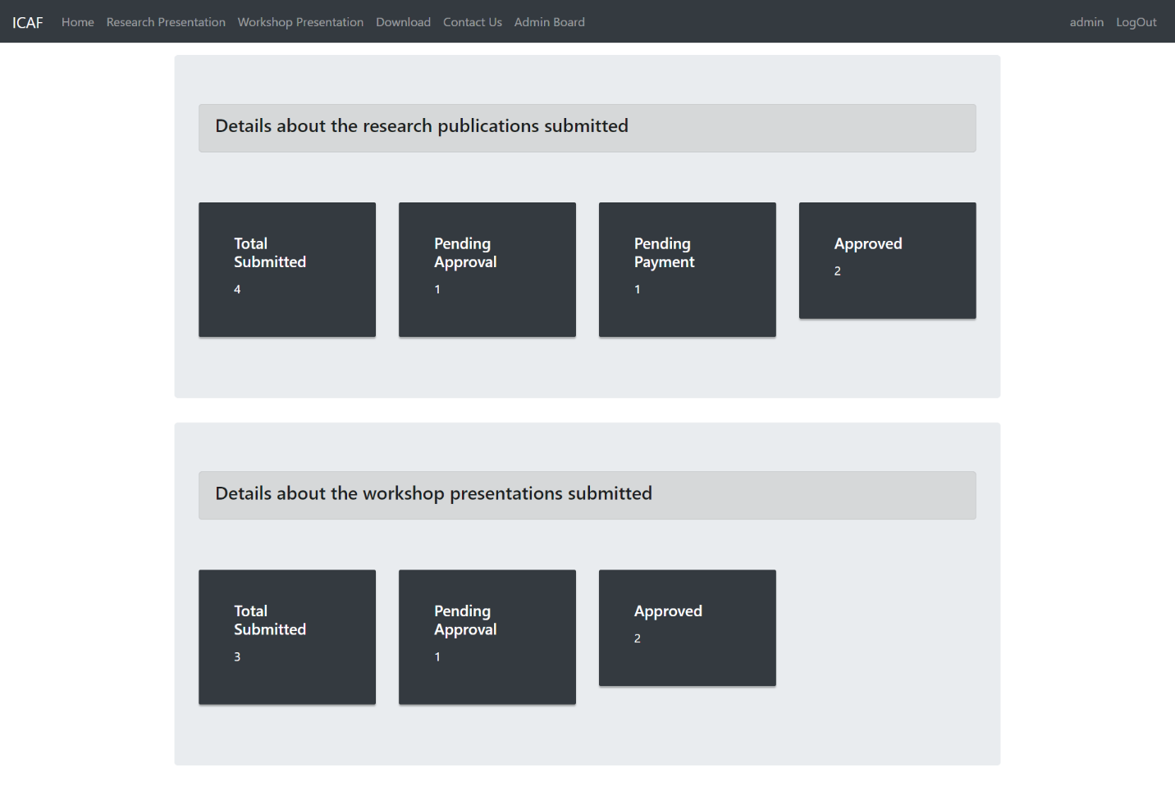Quantitative details about the research publications and workshop presentations submitted are available in the form of card for the admin to view at a glance.

All the details inserted by the Editor (using the relevant form – conference details / workshop details / research paper details) are displayed here.

1. Admin can view the relevant details and either Approve / reject the form details. If the Admin click on “Approve” button, the button changes to Approved.

**Conference Details**

**If Approved**

**Workshop Details**

**If Approved**

**Research Paper Details**

**If Approved**

1. The Approved details will be sent to each of the relevant pages (Home Page / Research Presentation / Workshop Presentation)

# Features available for a research publisher

## Research Publisher Board

The research publisher can view the approval status of the research publication that was submitted by the research publisher at registration. Research publisher is also able to view and download the research publication that was submitted by him/her.

By default, the approval status is set to “Not Approved”, which means the research publication has not been approved yet, by the reviewer.

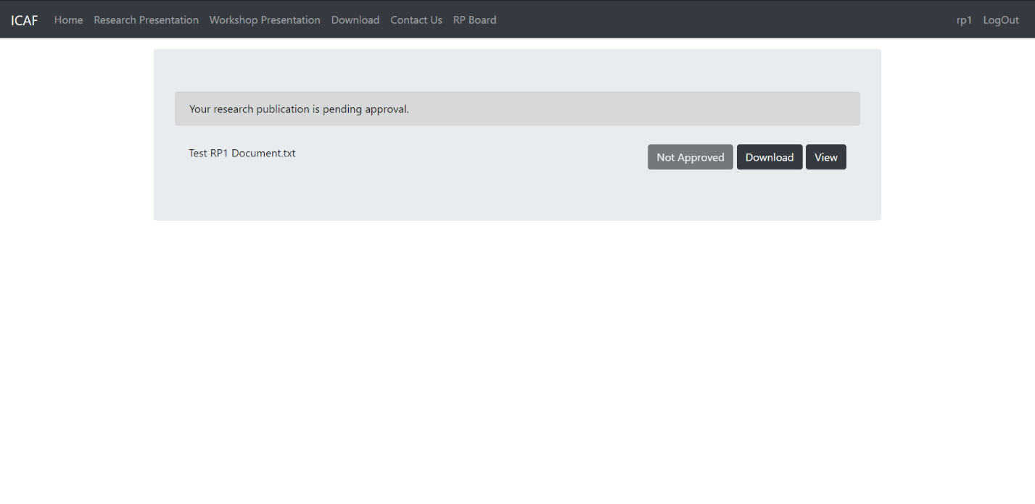

Once the reviewer approves the research publication (this step will be shown under features available for reviewer), the status of the research publication will be changed to “Pay”, which means it has been approved by the reviewer and the research presenter needs to pay to finalize the process and publish his publication.

Clicking on “Pay” (pointed to by the arrow) extends the row and displays a form to enter the payment details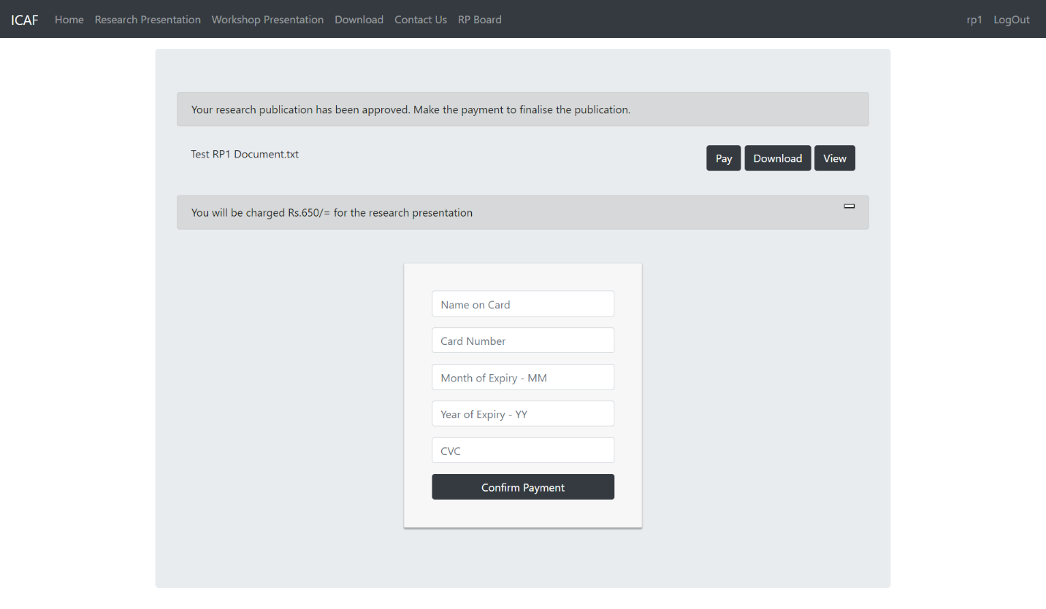.

Once the research publisher makes the payment, the status of the research publication will be changed to “Published”, which means, as the word itself describes, that it has been successfully published.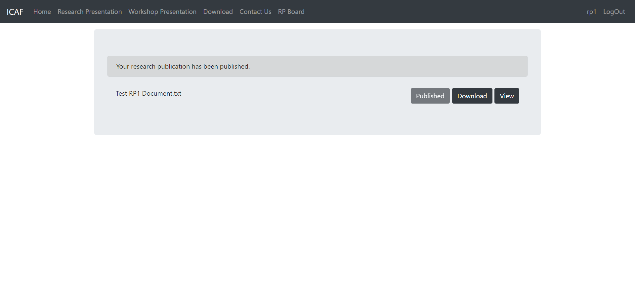

# Features available for a workshop presenter

## Workshop Presenter Board

The workshop presenter can view the approval status of the workshop presentation that was submitted by the workshop presenter at registration. Workshop presenter is also able to view and download the workshop presentation that was submitted by him/her.

By default, the approval status is set to “Not Approved”, which means the workshop presentation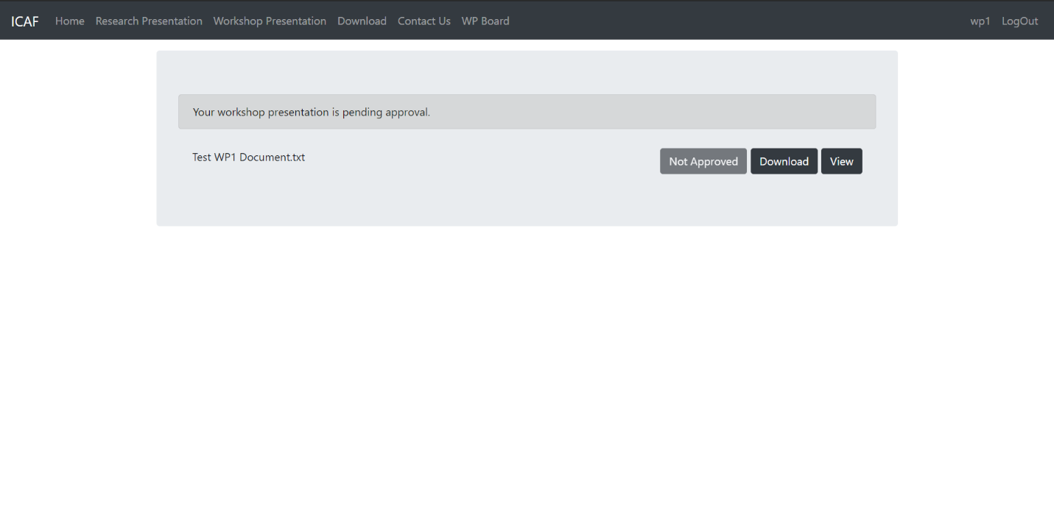 has not been approved yet, by the reviewer.

Once the reviewer approves the workshop presentation (this step will be shown under features available for reviewer), the status of the workshop presentation will be changed to “Approved”, which means, as the word itself describes, it has been approved.

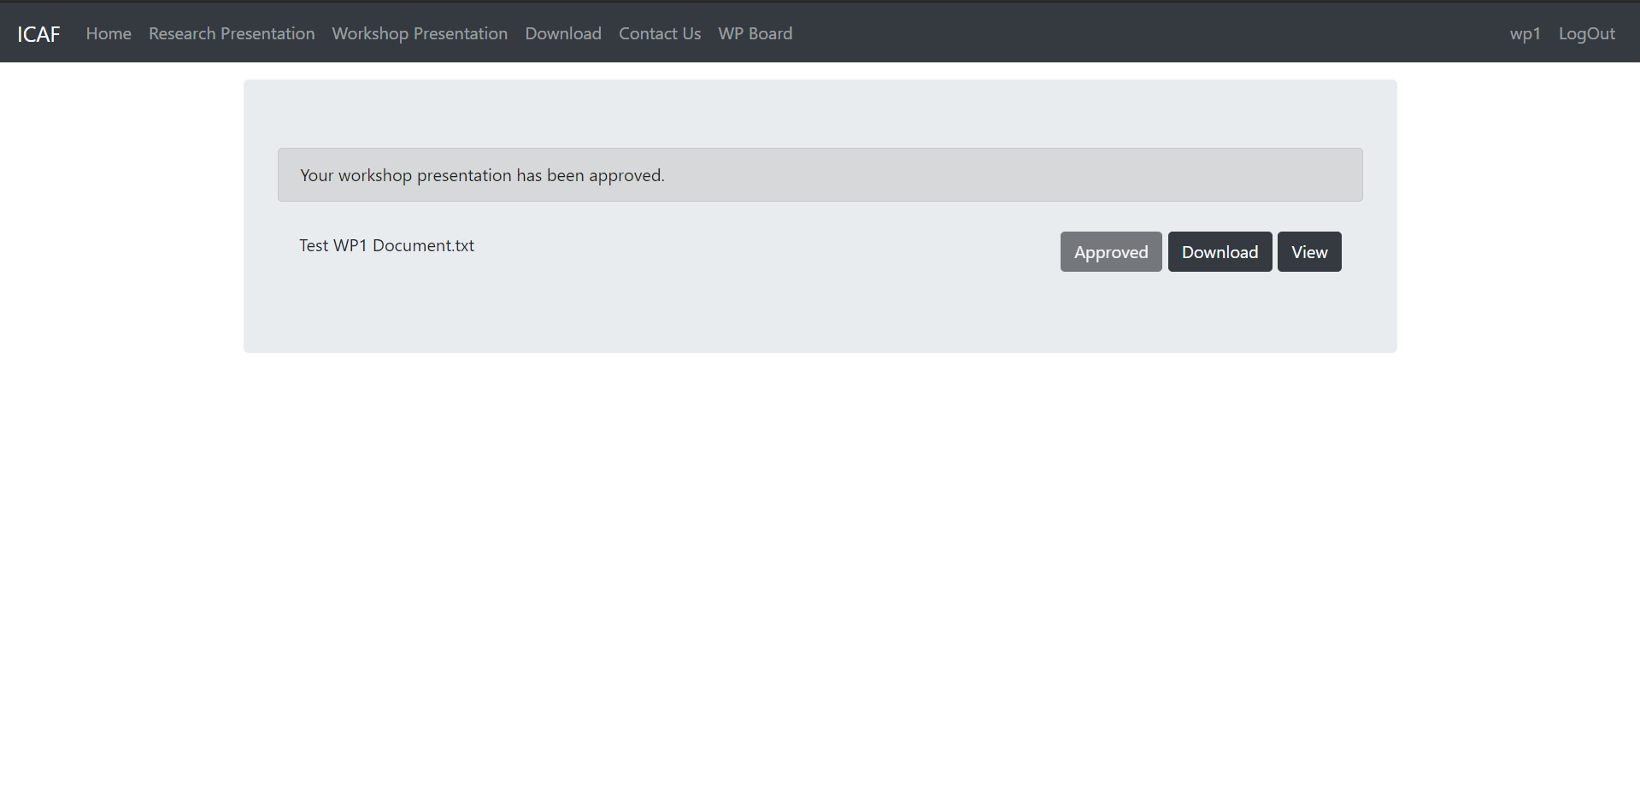

# Features available for an attendee

## Attendee Board

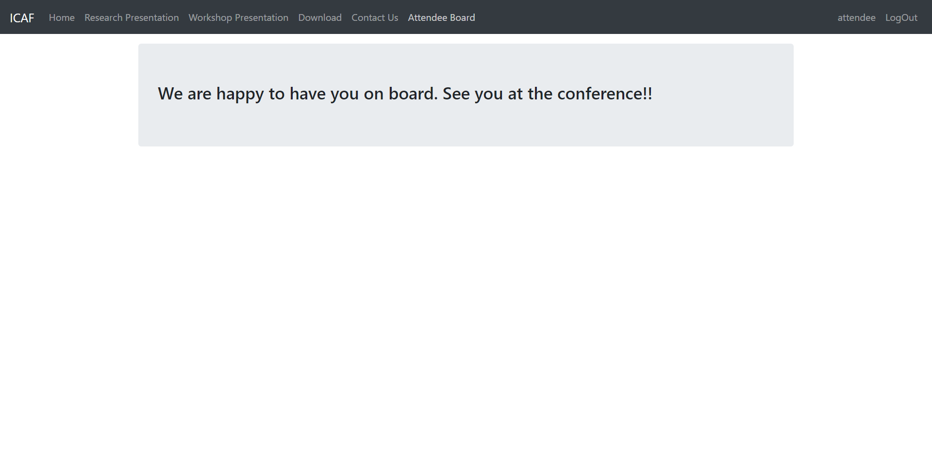

# Features available for an editor

## Editor Board

The Editor can log to site and enter the form details either related to Conference details or Workshop details or Research details.

**Conference Details**

**Workshop Details**

**Research Paper Details**

# Features available for a reviewer

The reviewer is presented with two links in the nav-bar pointing to two boards unlike other users. One for all the research publications submitted and the other for all the workshop presentations submitted.

## Reviewer board for research publications

The reviewer can view the approval status of the research publications submitted by the research publishers at registration and approve them if needed. Reviewer is also able to view and download the research publications.

By default, the approval status is set to “Approve”, clicking on it would change the approval status to “Payment Pending”, and the relevant research publisher will be notified to make the relevant payment to finalize the publication (the steps related to the payment is shown under, features available for research publisher).

Once the research publisher makes the payment the approval status will change to “Approved”.

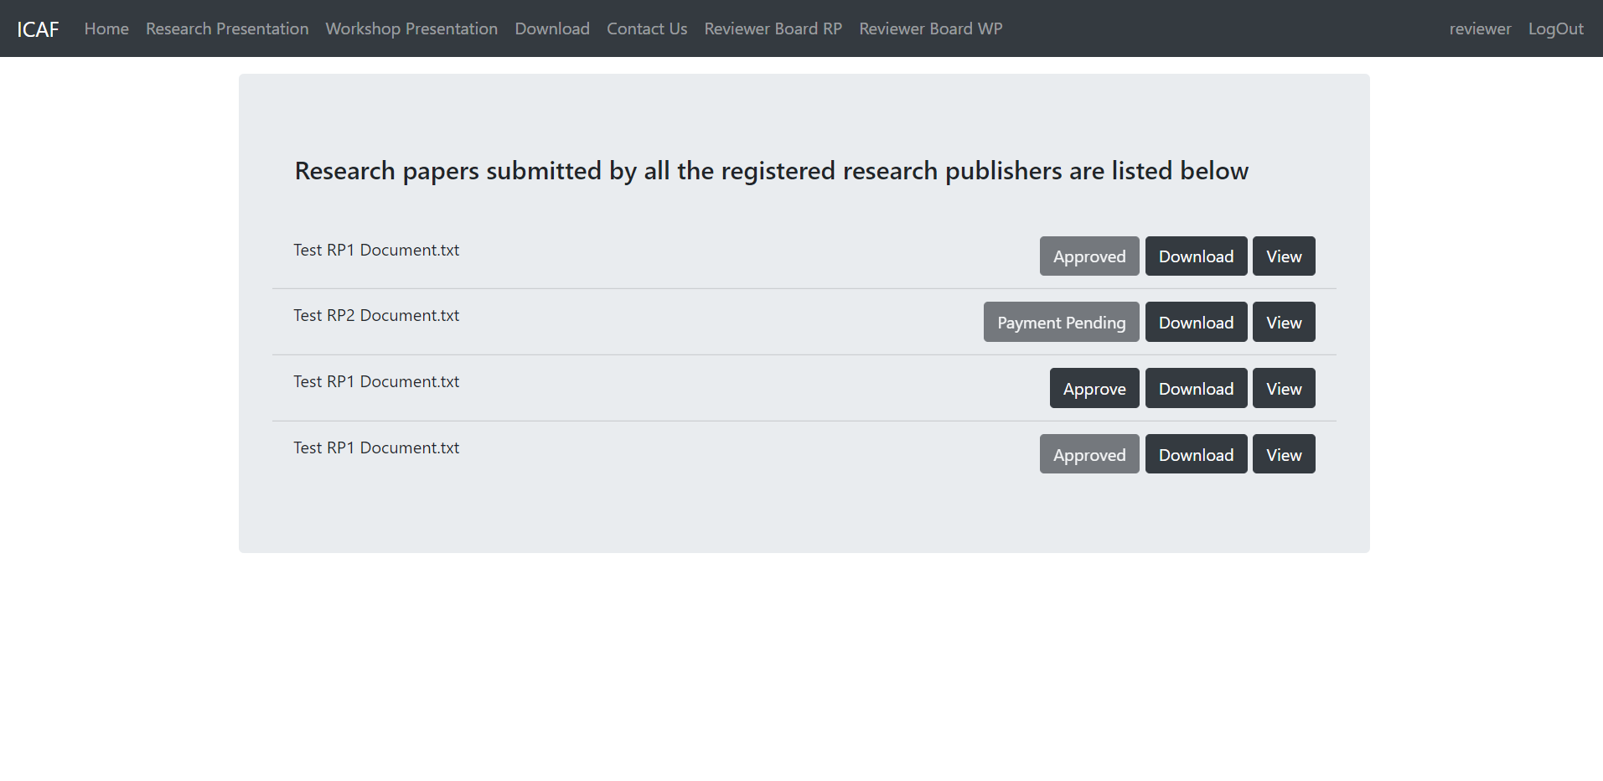

**Buttons/Approval status**

## Reviewer board for workshop presentations

The reviewer can view the approval status of the workshop presentations submitted by the workshop presenters at registration and approve them if needed. Reviewer is also able to view and download the workshop presentations.

By default, the approval status is set to “Approve”, clicking on it would change the approval status to “Approved”, which means, as the word itself describes, it has been approved.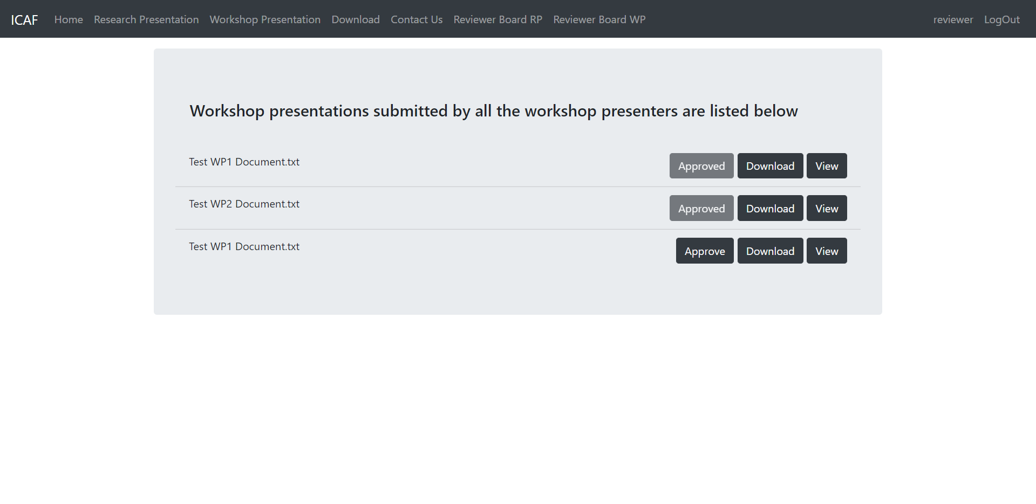

**Buttons/Approval status**